**EXPERIMENT NUMBER- 10**

**AIM**

* To display the multiplication table for the given number.

**DESCRIPTION**

* JavaScript is used to develop interactive web applications. JavaScript can power features like interactive images, carousels, and forms. The language can be used with back-end frameworks like Node. js to power the mechanics behind a web page. The required multiplication table can be created using JavaScript on the HTML page using the <script> tag.
* Here firstly, we will use the prompt message box of event handling to get the number for which the multiplication table is required. Then we will create an empty string and using a for loop, we will add each line of the multiplication table and finally used a document. write() function, we will print that table on the webpage.

**PROGRAM(S)**

<?xml version="1.0" encoding="UTF-8"?>

<!DOCTYPE html PUBLIC "-//W3C//DTD XHTML 1.0 Strict//EN"

"http://www.w3.org/TR/xhtml1/DTD/xhtml1-strict.dtd">

<html xmlns="http://www.w3.org/1999/xhtml" xml:lang="en" lang="en">

<head>

<title>Week1_Program-1</title>

</head>

<body>

<p id="demo"></p>

<script>

const num = parseInt(prompt("Enter a number: "));

var result = "";

for(let i=1;i<11;i++){

result = result + "<p>"+num+" x "+i+" = "+num*i+"</p>";

}

document.getElementById("demo").innerHTML=result;

</script>

</body>

</html>

**RESULTS/OUTPUT**

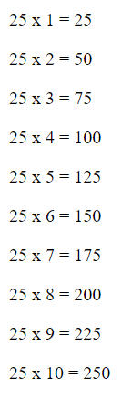

**CONCLUSION**

The multiplication table for the given number is displayed on the webpage using JavaScript.

**EXPERIMENT NUMBER- 11**

**AIM**

* To generate a multiplication table, ask the user to enter the number of rows and columns and if the user enters nothing or 0, then display a multiplication table with 10 rows and 10 columns.

**DESCRIPTION**

* JavaScript is used to develop interactive web applications. JavaScript can power features like interactive images, carousels, and forms. The language can be used with back-end frameworks like Node. js to power the mechanics behind a web page. To generate the multiplication table in the webpage, we will use JavaScript using the <script> tag.
* Here first we will take the number of rows and columns using the prompt() function, then check whether rows or columns are greater than zero and not null values, if the condition is false, we will print the table for 10 rows and 10 columns else we will generate the table for the given rows and columns using the nested for loops and <table> tag and its elements.

**PROGRAM(S)**

<!DOCTYPE html>

<html lang="en">

<head>

<title>Matrix Multiplication</title>

</head>

<body>

<script>

let row=prompt("Enter the Number of rows ");

let col=prompt("Enter the number of columns ");

document.write("<table border='1' align='center' cellspacing='0' cellpadding='14'>")

if(row==0 || row=="" || col==0 || col==""){

row=col=10;

}

for(let i=1;i<=row;i++){

document.write("<tr>")

for(let j=1;j<=col;j++){

document.write("<td>")

document.write(i*j);

document.write("</td>")

}

document.write("</tr>")

}

document.write("</table>")

</script>

</body>

</html>

**RESULTS/OUTPUT**

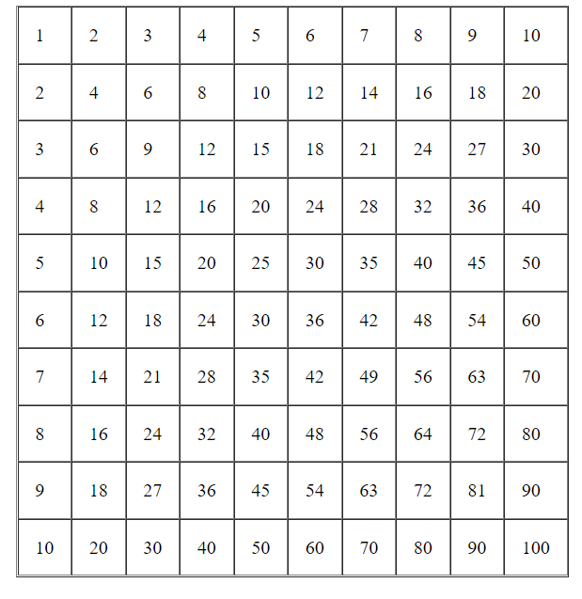

**CONCLUSION**

* The required multiplication table is successfully generated using JavaScript

**EXPERIMENT NUMBER- 12**

**AIM**

* To write a javascript function that converts Fahrenheit to Celsius.

**DESCRIPTION**

* JavaScript is used to develop interactive web applications. JavaScript can power features like interactive images, carousels, and forms. The language can be used with back-end frameworks like Node. js to power the mechanics behind a web page. Using JavaScript, <script> tag in an HTML page, we will display the Celsius value for the given Fahrenheit temperature using the document.write() function in the webpage.

**PROGRAM(S)**

<!DOCTYPE html>

<html lang="en">

<head>

<meta charset="UTF-8">

<meta http-equiv="X-UA-Compatible" content="IE=edge">

<meta name="viewport" content="width=device-width, initial-scale=1.0">

<title>Temprature Conversion</title>

</head>

<body>

<script>

function temp(f){

let tinC= ((f-32)*5)/9;

return tinC;

}

let f=prompt("Enter the temperature in Farenheit");

let tempindeg=temp(f);

document.write("<str>",f," farenheit"," = ",tempindeg," degrees celcius","</str>")

</script>

</body>

</html>

**RESULTS/OUTPUT**



**CONCLUSION**

* The JavaScript code successfully converts the temperature from Fahrenheit to Celsius

**EXPERIMENT NUMBER- 13**

**AIM**

* To write a JavaScript program that accepts a number as input and inserts dashes(-) between each two even numbers

**DESCRIPTION**

* JavaScript is used to develop interactive web applications. JavaScript can power features like interactive images, carousels, and forms. The language can be used with back-end frameworks like Node. js to power the mechanics behind a web page. Using JavaScript, <script> tag in the HTML page, we will write the logic to insert dashes between every two even numbers.
* In the <script> tag, we will get the input of the user using the prompt() function, then using the logic below we will print each character, and when we find two even numbers beside each other, then print the dash and continue with the next character, until all characters are done. We will print the characters using the document.write() function.

**PROGRAM(S)**

<!DOCTYPE html>

<html lang="en">

<head>

<title>Dashes 2 even</title>

</head>

<body>

<script>

let n=prompt("Enter the value of n ");

let le=n.length;

let arr=new Array(le);

let B=new Array(le);

console.log(arr);

for(let i=0;i<le;i++){

arr[le-i-1]=n%10;

B[le-i-1]=n%10;

n=Math.floor(n/10);

}

for(let i=0;i<le;i++){

arr[i]=arr[i]%2;

}

for(let i=0;i<le;i++){

document.write(B[i]);

if(i<le-1){

if(arr[i]==0 && arr[i+1]==0){

document.write("-");

}

}

}

</script>

</body>

</html>

**RESULTS/OUTPUT**



**CONCLUSION**

* The JavaScript code to insert dashes between two even numbers runs successfully and provides the correct output.

**EXPERIMENT NUMBER- 14**

**AIM**

* To write a JavaScript program to find the most frequent item of an array.

**DESCRIPTION**

* JavaScript is used to develop interactive web applications. JavaScript can power features like interactive images, carousels, and forms. The language can be used with back-end frameworks like Node. js to power the mechanics behind a web page. Using JavaScript, we have to find the most frequent item of an array
* Here we will declare a variable to store the frequency of each element, and after that, we will check for the largest value in those frequencies and finally print the element with the most frequency on the HTML page using the document.write() function.

**PROGRAM(S)**

<!DOCTYPE html>

<html lang="en">

<head>

<title>Frequency of Elements</title>

</head>

<body>

<script>

let arr=promt(“enter the elements”)

let result={};

for(index in arr){

if(result[arr[index]]){

result[arr[index]]+=1;

}

else{

result[arr[index]]=1;

}

}

let greatestfreq=0;

let great_val=null;

let flag=0;

for(element in result ){

if(greatestfreq<result[element]){

flag=1;

greatestfreq=result[element];

great_val=element;

}

else if(greatestfreq==result[element]){

flag=0;

}

}

if(flag==1){

document.write("<str>",great_val," is the highest occuring element with frequency "," - ",greatestfreq,"</str>","<br>");

}

else{

document.write("There are more than 1 element with greatest frequency");

}

</script>

</body>

</html>

**RESULTS/OUTPUT**



**CONCLUSION**

* The JavaScript code to find the most frequent item of an array runs successfully and gives the required output.